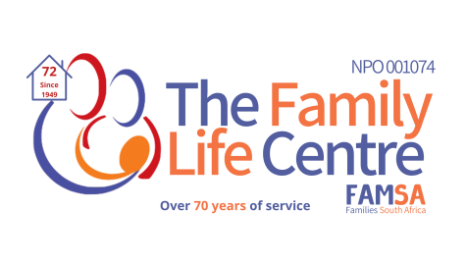
TRAINING
PROGRAMMES
2022
FAMILY LIFE CENTRE
TRAINING REGISTRATION FORM
To be completed by a prospective participant wishing to enrol for a training programme at The Family Life Centre. Please complete the information below and return this form to the training department via email before commencing with the training programme. The filling and submission of this form will fulfil the registration requirements of the course you have applied for.

IMPORTANT: PLEASE CLEARLY TYPE THE CORRECT NAME THAT YOU WOULD LIKE TO APPEAR ON YOUR CERTIFICATE.

In order to maintain a high standard of our training programmes and to comply with the COVID 19 protocols as pronounced by government, we have a minimum and a maximum number of participants per training group. The number of participants permissible will be determined by the COVID 19 guidelines as stipulated by the government and by the course requirements. We require that you take the necessary precautions such wearing a mask, maintaining a social distance and sanitizing your hands at all times.

PERSONAL DETAILS:
TITLE: |  |  | SEX: |  |  | M | F |  | other
LEGAL NAME: |  | LAST NAME |  |  |  |  |  | FIRST NAME |  |  |  | MIDDLE NAME
DATE OF BIRTH |  |  |  |  | ID/PASSPORT NUMBER |  |  |  |  |  |  |  |  | AGE
RESIDENTIAL ADDRESS:

POSTAL ADDRESS:
(Tick if address is the same as Residential address):

TELEPHONE NUMBERS: |  |  |  | Home: |  |  |  |  |  | Work: |  |  | Cell no:
Email address:
Work Address:

Qualifications:
Present Occupation:
Previous experience in this field, if any:

COURSE INFORMATION:
COURSE ENROLLED:
DATE OF COURSE:
PLEASE NOTE: ATTENDANCE OF ALL TRAINING SESSIONS IS COMPULSORY FOR OBTAINING A CERTIFICATE
FINANCIAL INFORMATION:
PLEASE NOTE: In order to secure a place for you for the course of your choice, we request a 50% enrolment fee to be paid at least 2 weeks prior to the start of the course.
A cancellation fee of 50% of the balance will be due should cancellation occur within 7 working days prior to the training.

BANKING DETAILS:

BENEFICIARY: The Family Life Centre
BANK: Nedbank, Northern Gauteng
Branch Code: 198765
Account no: 146 901 6397
Account type: Cheque Account
PLEASE SEND PROOF OF PAYMENT TO finance@familylife.co.za or training@familylife.co.za

ADDITIONAL INFORMATION:
Reasons for wanting to do this course:
Special dietary requirements?

Where did you hear about this us or this course:
Would you like to be added onto our database for information on future courses/workshops?

We require updated pictures from time to time to promote our courses on social media, our website and all our marketing materials. These pictures will be shared by us (The Family Life Centre) only and they will not be shared without your consent, do you give consent to us take and share a picture of you during training? Yes No
PLEASE NOTE:
Should it be necessary, participants will be informed of any date or time changes

I hereby declare that the foregoing information contained in this document is true and correct and I understand that should any of this information discovered to be untrue, my attendance to the course at The Family Life Centre will be terminated and I will be prohibited from continuing to attend this any further.
Full Name:__________________________________________
Signature:____________________________
Date:__________________________

Further enquiries regarding training can be directed to the Training Department at training@familylife.co.za or patricia@familylife.co.za, Tel: 011 788 4784

